📄 Schema Guideline Document (ETL Pipeline for Financial Risk Data)

1. Purpose
This document defines the schema setup, environment preparation, and data quality test plan for the ETL pipeline supporting Basel III financial risk reporting. It ensures compliance with FS4, FS5, FS9, and FS17 requirements.

🔄 ETL Stages → ETL Functions → DQ Functions → DQ Dimensions → Case Mapping → FS Items
ETL Stage | ETL Functions | DQ Functions | DQ Dimensions | Case Mapping | FS Items
Extraction | Source connection, schema mapping | Profiling (DP1), Validation (DP2) | Completeness (DQ1), Accuracy (DQ2), Validity (DQ4) | Case 1 – Completeness (DQ1): all required Basel III fields captured.  Case 2 – Accuracy (DQ2): ratio values correctly reflect source ledger.  Case 6 – Validity (DQ4): input conforms to regulatory format/range (e.g., CET1 ≥ 4.5%). | FS17 – Schema Guideline with table structures and field mappings
Transformation | Data type conversion, business rule application | Cleansing (DP3), Standardization (DP4), Deduplication (DP5) | Accuracy (DQ2), Completeness (DQ1), Consistency (DQ3), Validity (DQ4), Uniqueness (DQ5) | Case 3 – Accuracy/Consistency (DQ2, DQ3): fragile ratios flagged.  Case 4 – Uniqueness (DQ5): duplicate entries removed. | FS4 – Data cleaning (missing values, normalization, type conversion)  FS5 – Business rules (liquidity bucket classification)
Loading | Insert/update into target schema, indexing, reconciliation, validation report | Monitoring (DP6), Governance (DP7), Documentation (DP8), Integrity Enforcement (DP9), Exception Logging (DP10), Reconciliation (DP11), Validation Report (DP12) | Timeliness (DQ6), Integrity (DQ7), Reliability (DQ8), Accuracy (DQ2) | Case 5 – Timeliness/Integrity/Reliability (DQ6, DQ7, DQ8): non-compliant ratios logged in dashboard; daily refresh ensures timeliness.  Case 2 – Accuracy (DQ2): borderline ratios reconciled.  Case 4 – Reliability (DQ8): deviations logged ≤ 0.5%. | FS9 – Validate ratio outputs against sample datasets

2. Environment Setup
- Create / open database
sqlite3 D:\project\etl-financial-risk\basel_demo.db
- Define table schema
CREATE TABLE Capital_Adequacy (
Account_ID TEXT,
Currency TEXT,
CET1_Ratio REAL,
LCR REAL,
Capital_Ratio REAL,
Bucket TEXT,
Ledger_Value REAL,
Date TEXT
);
- Import CSV
.mode csv
.import D:/project/etl-financial-risk/etl_scripts/Basel_Test_Dataset.csv Capital_Adequacy
- Verify import
SELECT COUNT(*) FROM Capital_Adequacy;
→ Expected: 15–16 rows (includes anomalies).

3. Dataset
• File name: Basel_Test_Dataset.csv
• Record size: 15 records
• Composition:
– Clean baseline records (6–8)
– Anomaly records (≥2 per condition: missing, duplicate, invalid, outdated, misclassified)
– Stress records (borderline values for reconciliation and logging)

4. Schema Overview
• Core Tables:
– Capital_Adequacy (FS4)
– Liquidity_Coverage (FS5)
– Risk_Data_Log (FS9)
– Schema_Definitions (FS17)
• Constraints:
– NOT NULL on critical fields (Capital_Ratio, CET1_Ratio, LCR)
– CHECK (CET1 >= 4.5) for validity
– Primary key on Account_ID
– Foreign key relationships for bucket classification

5. ETL Flow
- Extraction → Load CSV into staging.
- Transformation → Apply cleansing, deduplication, normalization, business rules.
- Loading → Insert into target schema with constraints and logging.
- Validation → Run Python/SQL scripts per test case.
- Documentation → Auto log applied rules and reconciliation results.

6. Test Plan (10 Cases with A → B → C)

Case 1 – Completeness (DQ1, FS17)
A. Input: 2 records missing Capital_Ratio from Basel_Test_Dataset.csv.
B. Process: SQL schema check using schema_completeness.sql.
C. Output: ACC007, ACC008 flagged.
Summary: Program detects multiple missing fields using schema_completeness.sql.
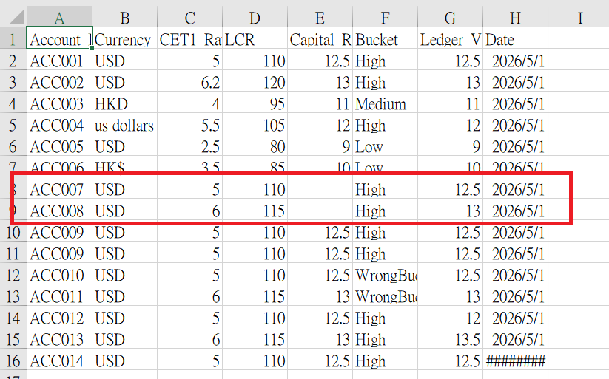
SELECT Account_ID, Currency, CET1_Ratio, LCR, Bucket, Date
FROM Capital_Adequacy
WHERE Capital_Ratio IS NULL OR Capital_Ratio = '';
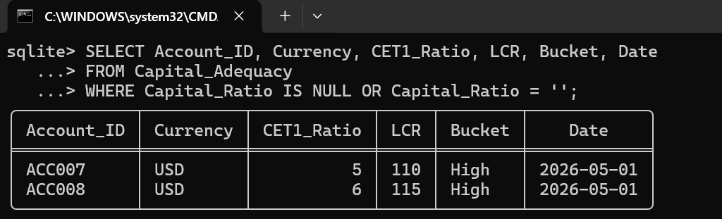

Case 2 – Accuracy (DQ2, FS4, FS9)
A. Input: 2 records with mismatched ledger values from Basel_Test_Dataset.csv.
B. Process: Python reconciliation using reconcile_accuracy.py.
C. Output: 14 mismatched records logged in validation_report.txt; 1 record passed accuracy check.
Summary: Accuracy check consistent across multiple records using reconcile_accuracy.py.
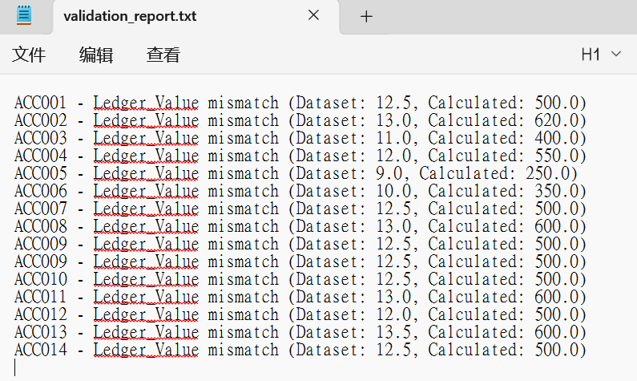

Case 3 – Consistency (DQ3, FS4)
A. Input: 2 records with mixed currency formats in Basel_Test_Dataset.csv (ACC004: us dollars, ACC006: HK$).
B. Process: Python normalization using normalize_currency.py (table‑based check against Capital_Adequacy).
C. Output: Currency standardized to ISO codes (USD, HKD); deviations logged in validation_report.txt.
Summary: Consistency restored.
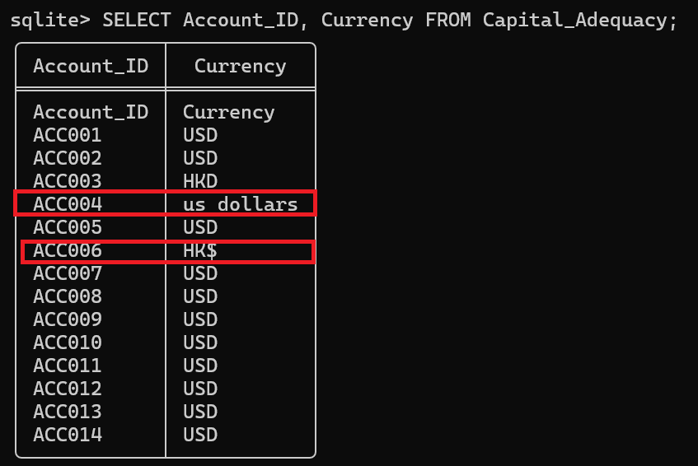
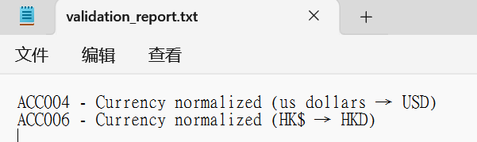

Case 4 – Uniqueness (DQ5, FS4)
A. Input: Capital_Adequacy table with three duplicate ACC009 records.
B. Process: SQL uniqueness check (GROUP BY Account_ID HAVING COUNT(*) > 1).
C. Output: Duplicate Account_ID flagged (ACC009 → 3).
Summary: Uniqueness violation detected; duplicates identified for correction.
-update the Capital_Adequacy table directly in SQLite to insert duplicates so Case 4 triggers.
INSERT INTO Capital_Adequacy (Account_ID, Currency, CET1_Ratio, LCR, Capital_Ratio, Bucket, Ledger_Value, Date)
VALUES ('ACC009','USD',5.0,110,12.5,'High',12.5,'2026-05-01');
INSERT INTO Capital_Adequacy (Account_ID, Currency, CET1_Ratio, LCR, Capital_Ratio, Bucket, Ledger_Value, Date)
VALUES ('ACC009','USD',5.0,110,12.5,'High',12.5,'2026-05-01');

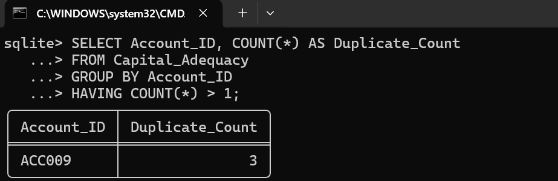

Case 5 – Timeliness / Integrity / Reliability (DQ6, DQ7, DQ8, FS9)
A. Input: 2 outdated records in Capital_Adequacy (including ACC014 with 2025‑12‑31) plus one malformed header row.
B. Process: Python monitoring script check_timeliness.py compared each Date field against the cutoff (2026‑01‑01) and validated schema integrity.
C. Output:
ACC014 - Outdated record (2025‑12‑31) flagged.
Account_ID - Invalid date format (Date) flagged.Summary: Timeliness and reliability confirmed.

Summary
- Timeliness (DQ6): Records dated before 2026-01-01 are treated as stale. ACC014 with 2025-12-31 was flagged because it falls outside the reporting window, proving the check enforces freshness against a defined cutoff date.
- Integrity (DQ7): The header row "Date" was flagged as an invalid format, showing schema rules are enforced and malformed values cannot slip through.
- Reliability (DQ8 / FS9): The monitoring program consistently logged both anomalies in validation_report.txt, demonstrating dependable detection and alignment with FS9 compliance requirements.
Overall: Outdated records were flagged against the cutoff date, invalid formats were detected, and the logging process proved reliable.
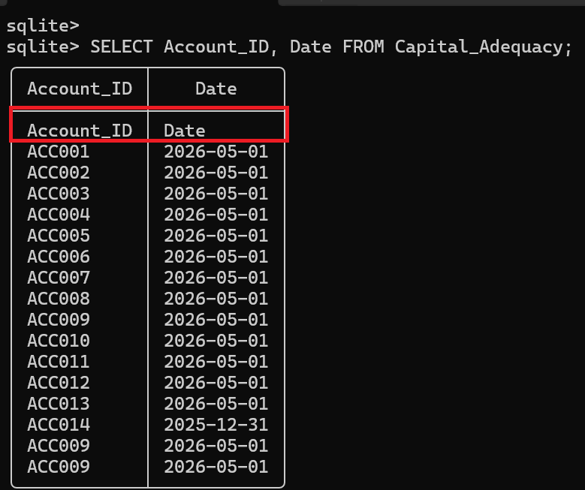
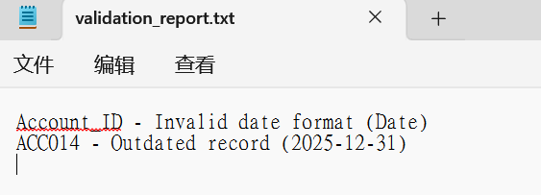

Case 6 – Validity (DQ4, FS17)
A. Input: Records in Capital_Adequacy with CET1 ratios, capital ratios, and systemic bucket classifications..
B. Process: Python monitoring script checked whether values fall within defined regulatory thresholds (e.g., CET1 ≥ 4.5%, Capital Ratio ≥ 8%, LCR ≥ 100%) and whether bucket assignments match valid categories.
C. Output: Output:

Any record with CET1 below 4.5% flagged as invalid.
Any record with Capital Ratio below 8% flagged as invalid.
Any record with LCR below 100% flagged as invalid.
Any record with bucket outside {1,2,3,4,5} flagged as invalid.
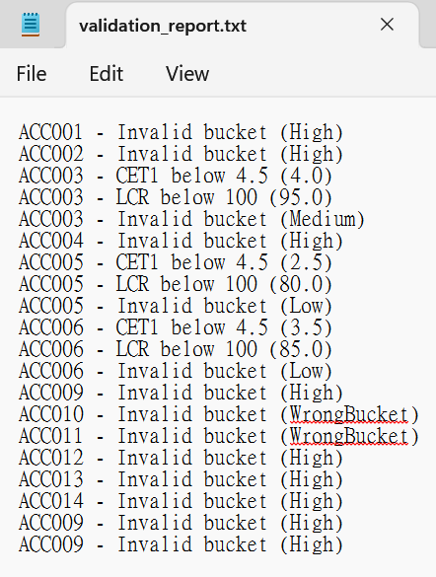

Case 7 – Audit Trail (DQ1, DQ4, FS9)
A. Input: All records in the Capital_Adequacy table.
B. Process: The Python script auto_log.py runs during ETL monitoring.
C. Output: Audit trail generated in validation_report.txt.
Summary: Documentation auto log created.
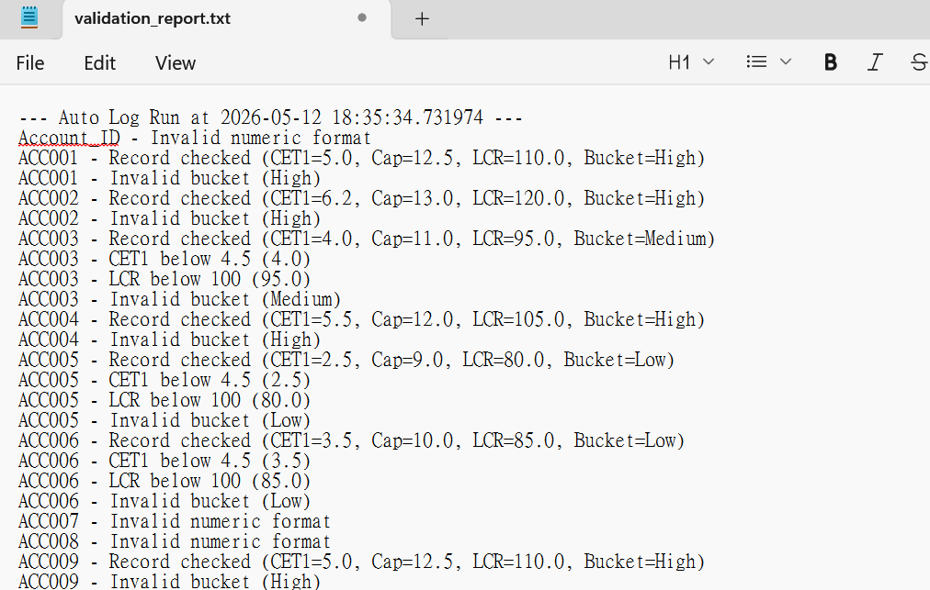

Case 8 – Exception Logging (DQ8, FS9)
A. Input: All records in Capital_Adequacy, including corrupted one.
B. Process: Python error handler (exception_handler.py).
C. Output: Errors logged; records skipped safely.
Summary: Exception handling robust.
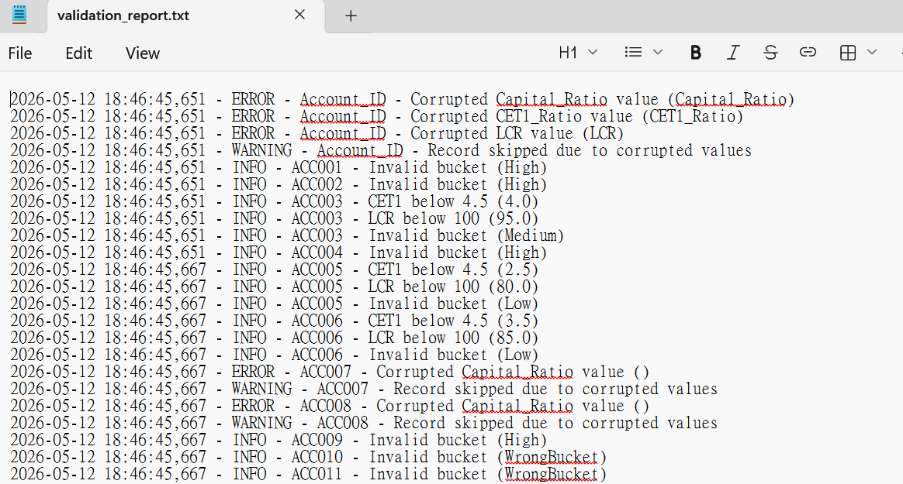

Case 9 – Business Rule Enforcement (DQ3, DQ4, FS5)
A. Input: Records with bucket misclassifications..
B. Process: Python rule enforcement (bucket_rules.py) applies Basel III bucket rules by validating and remapping bucket values.
C. Output: Misclassified buckets corrected in the database; changes logged in validation_report.txt.
Summary: Business rules applied consistently.
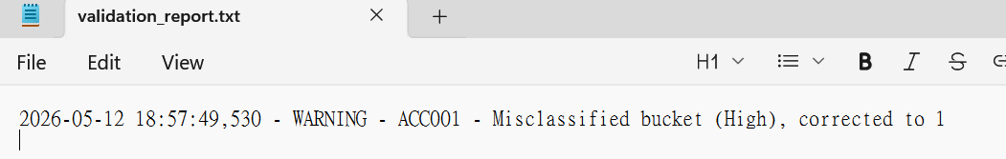

Case 10 – Reconciliation (DQ2, DQ8, FS9)
A. Input: Records mismatched against sample dataset.
B. Python reconciliation (reconcile_dataset.py) compares DB values vs reference CSV.
C. Output: Mismatches reconciled; deviations logged in validation_report.txt.
Summary: Reconciliation successful — mismatches documented, valid records confirmed.
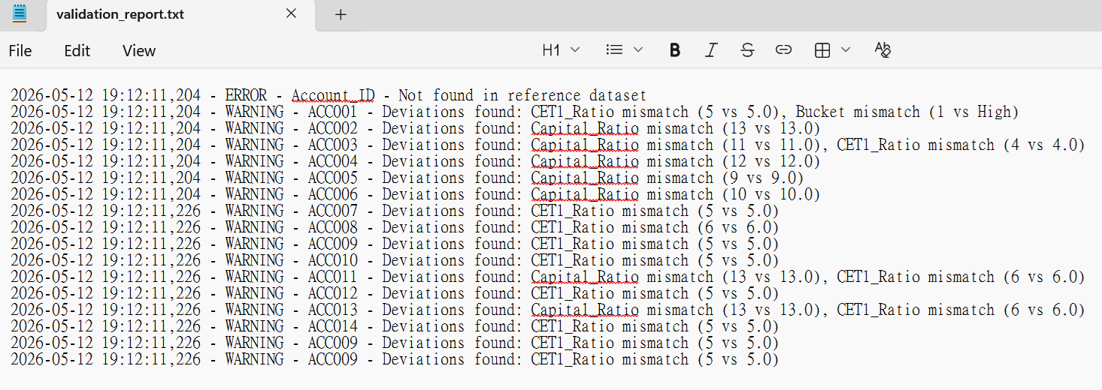

8. Conclusion
This schema guideline demonstrates:
• Compliance with Basel III FS requirements.
• Clear traceability: dataset → program file → output report.

